 | SWBAT explain the basic structures and functions of a flowering plant
 | Read the Plant Introduction CK12 Flexbook. Rally Tennis with your shoulder partner as you take turns sharing key facts learned from the reading.
 | Watch the Crash Course video on vascular plants. When you are done, watch the video on phloem and zylem and visit the phloem and zylem page from Biology4kids site. Finally, share out with a shoulder partner.
Structure/Function of Flowering Plants & Flowers | STRUCTURE AND FUNCTION OF FLOWERING PLANTS  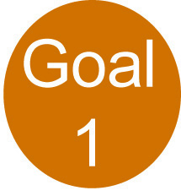  (Pick any 4 from the choices below) | STRUCTURE AND FUNCTION OF FLOWERS  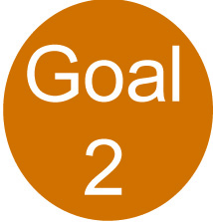  (Pick any 4 from the choices below)
 | Choice A – Watch the YouTube video on the structure of a flowering plant and the YouTube video on the parts of a plant. | Choice A – Watch the YouTube video on reproduction of flowering plants.
 | Choice B –.Look over the note page which shows a diagram, terms, and definitions for the parts of a plant. | Choice B – Look over the note page which shows a diagram, terms, and definitions for the parts of a flower.
 | Choice C – Play the labeling game as you practice labeling the parts of a plant. | Choice C – Learn about flowers and pollinators with Discovery Ed’s Flower Power Exploration.
 | Choice D – Practice building a plant with Discovery Ed’s Build a Plant Exploration. | Choice D – Participate in this interactive about the parts of a flower.
 | Choice E – Practice with identifying the structure and function of the parts of a flowering plant with the Discovery Ed Skill Builder. | Choice E - Practice labeling the parts of a flower with this labeling game.
 | Choice F – Explore flowering plants and the role of pollinators in Discovery Ed’s Flowering Plants Exploration. | Choice F – This is a good labeling quiz to play right before your check up on the parts of a flower.
 | Summarizer – After each goal, table talk with people around you and discuss key points learned from the material that you chose.
Coaching Points | 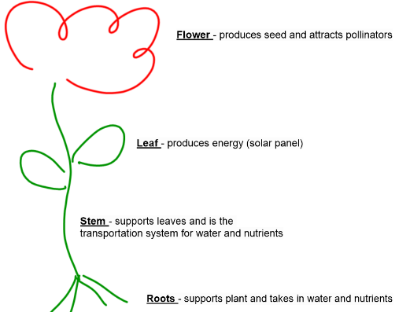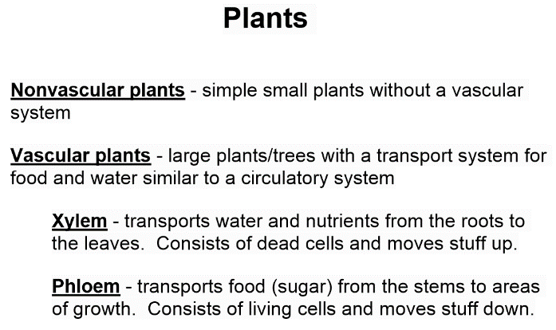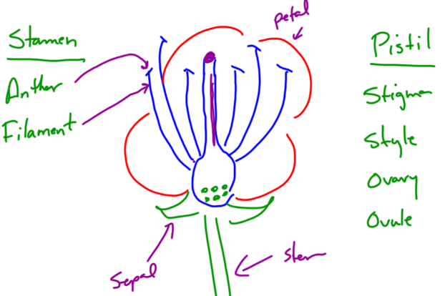

Quiz Preparations

QUIZ | Step 1 – Read over the selected study guide multiple times. | Step 2 – Using Rally Tennis, spend another 10 minutes summarizing key points about the unit. | Step 3 – Play Quizizz in class and try to score 80% or better. Your teacher will provide you with the class code. | Step 4 - Take your quiz and post your answers to Edmodo. Your teacher will provide you with directions for credit recovery if you score below an 80%.

