 | SWBAT explain the processes of photosynthesis, respiration, and transpiration to the survival of green plants and other organisms.
 | View the SlideShare presentation which highlights the three plant processes necessary for the survival of plants.
 | Read the CK12 article which explains the relationship between photosynthesis and respiration.
Plant Processes | PHOTOSYNTHESIS (Pick any 4 from the choices below) | RESPIRATION  (Pick any 4 from the choices below) | TRANSPIRATION  (Pick any 4 from the choices below)
 | Choice A – Watch these YouTube videos on photosynthesis: Video #1, Video #2, Video #3 | Choice A – Watch these YouTube videos on respiration: Video #1, Video #2, Video #3 | Choice A - Watch these YouTube videos on transpiration: Video #1, Video #2
 | Choice B –.View the SlideShare presentation on photosynthesis | Choice B – Read more about plant respiration on the Biology4kids site | Choice B – Watch the Discovery Ed animation on transpiration
 | Choice C – Learn more about photosynthesis with Discovery Ed’s Exploration activity | Choice C – View BBC’s Bitesize site to learn about respiration in plants | Choice C - Learn about what factors affect the rate of transpiration with this virtual lab
 | Choice D – Read the two page Discovery Ed reading passage about photosynthesis | Choice D – Explore the SEPUP simulation on photosynthesis and plant respiration | Choice D – Learn more about the stomata and see a real life example under a microscope
 | Choice E – Learn about photosynthesis with the Study Jams interactive lesson | Choice E - Click here for a definition of respiration | Choice E –Try this ClassZone virtual lab on transpiration
 | Choice F – Use the Discovery Ed Exploration activity to learn more about leaves and their role in photosynthesis | Choice F – Learn about photosynthesis and plant respiration with this virtual lab | Choice F – Visit the Pearson site to learn the role of guard cells with transpiration
 | Summarizer – After each goal, table talk with people around you and discuss key points learned from the material that you chose.
Coaching Points | 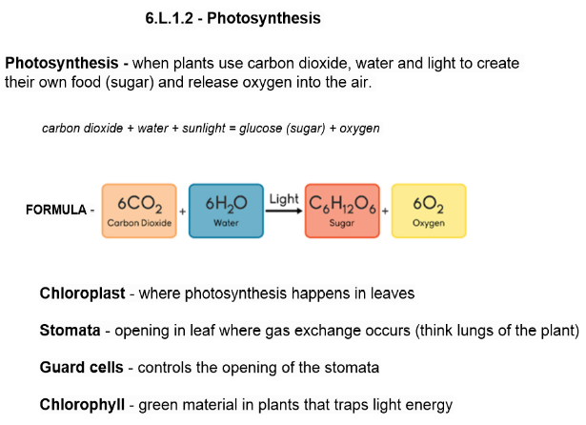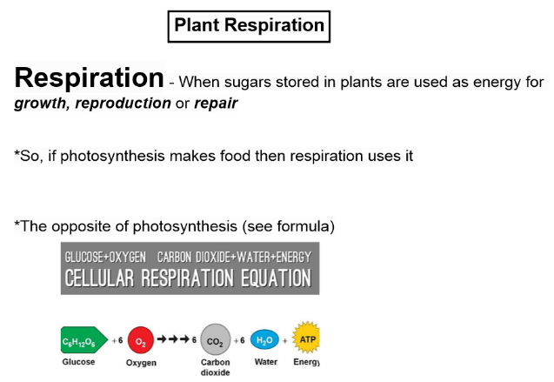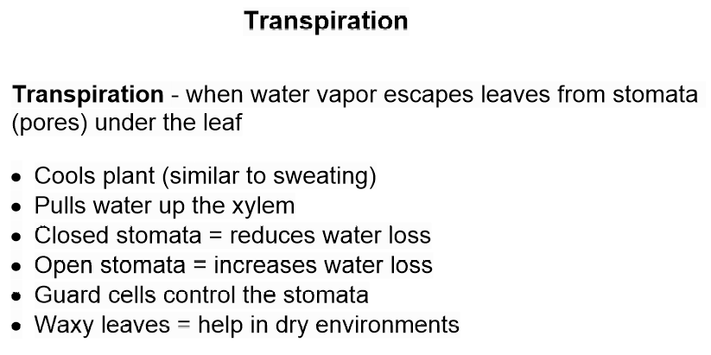

Quiz Preparations

QUIZ | Step 1 – Read over the selected study guide multiple times. | Step 2 – Using Rally Tennis, spend another 10 minutes summarizing key points about the unit. | Step 3 – Play Quizizz in class and try to score 80% or better. Your teacher will provide you with the class code. | Step 4 - Take your quiz and post your answers to Edmodo. Your teacher will provide you with directions for credit recovery if you score below an 80%.

