Name_______________
(6.L.1) - Plant Study Guide
Draw and Label the parts of a plant, including
the roots, stem, leaves, and flower.
What is the function (job) of the root?
What is the function (job) of the stem?
See picture above.
What is the function of flowers?
What is the function of leaves?
Plants can be divided into what two groups?

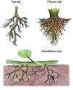

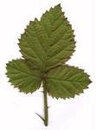

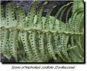
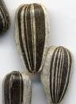

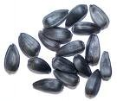
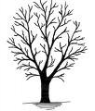
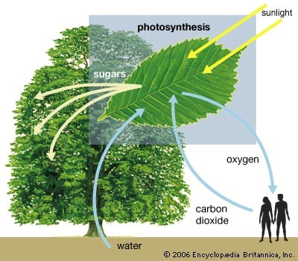
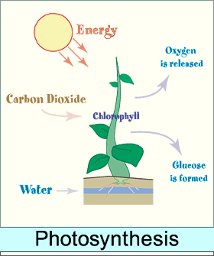
What is photosynthesis?
What is chlorophyll?
What 4 elements mix during photosynthesis?
What is produced during photosynthesis?
Where does photosynthesis occur?
Why are animals/people and plants
interdependent?
What is dormancy?

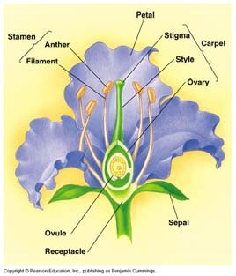
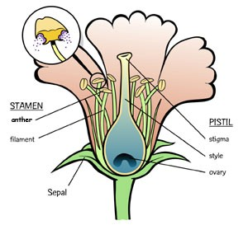
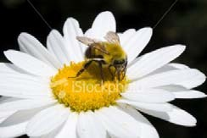
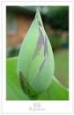
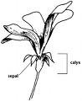
What is the function of the sepal?
What is the function of the petals?
What is the function of the stamen?
What is the function of the pistil?
(see picture above)
What is the function of the ovary?
(see picture above)
What is the function of the ovule?

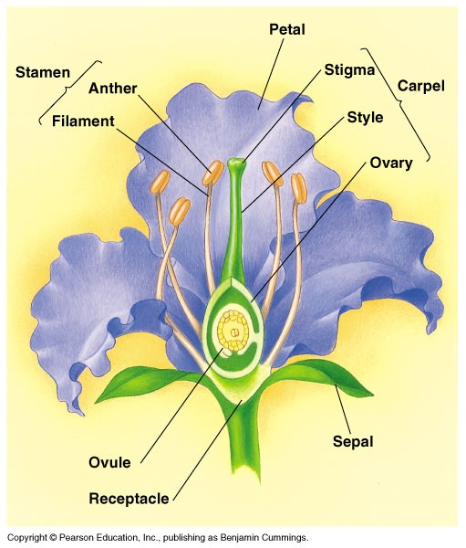
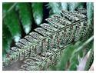
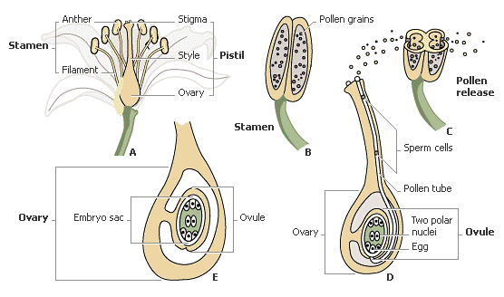
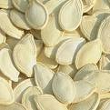
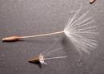
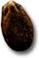
What is the function of the seed?
What is pollination?
How can plants be pollinated?
What are 2 examples of plants that reproduce
with spores?
How do plants with spores reproduce?
Draw and label the parts of a FLOWER.
Include the stamen, pistil, sepal, ovary, ovule, and seed

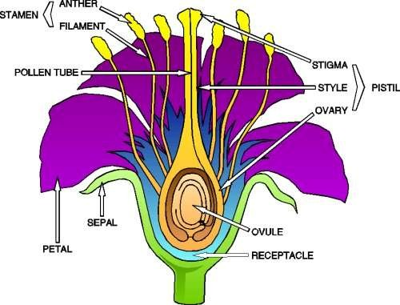
You should be able to EXPLAIN photosynthesis
in complete sentences.
You should be able to EXPLAIN the
reproductive processes in flowering plants in
complete sentences.
Explain the difference between vascular and non-vascular plants.

Explain the difference between a gymnosperm and angiosperm.

Explain stomata and guard cells?

Explain transpiration.

Explain respiration.

Explain how plants defend themselves.

