Plants - Study Guide Name___________________
Structure/Function of a Plant
Directions: Use the image to match the plant part to its name (A-D) and function (1-4). Write the correct letter and number on the line.
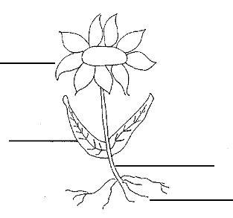
Plant Structure:
A – Stem B – Root
C – Leaf D – Flower
Plant Function:
1 – produces energy (solar panels)
2 – produces seeds and attracts pollinators
3 – supports plant and takes in water and nutrients
4 – supports leaves and is the transportation system for water and nutrients

Structure of a Flower
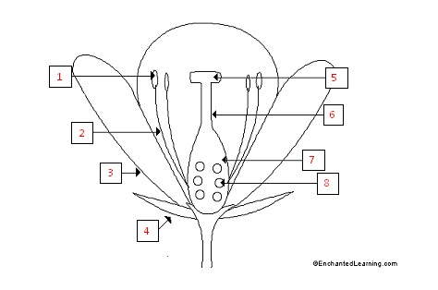
______ anther _____ filament _____ovary _____ ovule
_____ petal _____ sepal _____ stigma _____ style
Survival, Reproduction or Defense?
Directions: Check all functions that apply for each part of a plant and flower.
Survival | Reproduction | Defense
Plant Structure  ____ root ____ stem  ____ flower ____ leaf  Flower Structure  ____ anther ____filament  ____stigma ____ style  ____ovary ____ ovule  ____ sepal ____ petal | Plant Structure  ____ root ____ stem  ____ flower ____ leaf  Flower Structure  ____ anther ____filament  ____stigma ____ style  ____ovary ____ ovule  ____ sepal ____ petal | Plant Structure  ____ root ____ stem  ____ flower ____ leaf  Flower Structure  ____ anther ____filament  ____stigma ____ style  ____ovary ____ ovule  ____ sepal ____ petal

Photosynthesis, Respiration or Transpiration?
____________________ - When plants use carbon dioxide, water and light to create their own food (sugar) and release oxygen into the air.
____________________ - When sugars stored in a plant is used as energy for GROWTH, REPRODUCTION or REPAIR.
____________________ - When water vapor escapes a leaf from the stomata under the leaf

Formulas – Photosynthesis or Respiration?
_____________________ - 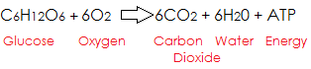
_____________________ - 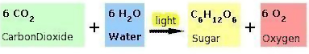

Phloem or Xylem?
___________________ - Transports water and nutrients UP from the roots to the leaves.
___________________ - Transports food (sugar) DOWN from the stem to areas of growth.

Stomata or Guard Cells
__________________ - Opening (pore) in the leaf where water vapor escapes
__________________ - Controls the opening in the leaf

