6.L.1.1 I can summarize the basic structures and functions of flowering plants required for survival, reproduction and defense.
I will identify the structures of a flowering plant.
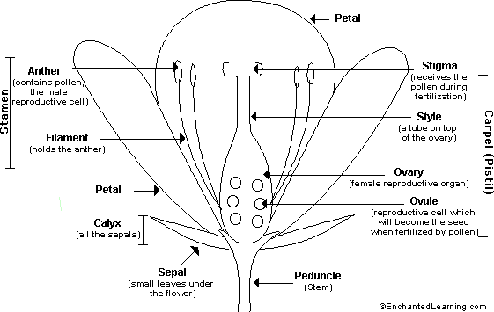
I will explain the reproductive process in flowering plants.
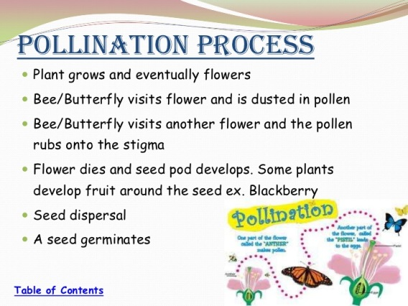
I will identify plant structures used for defense.
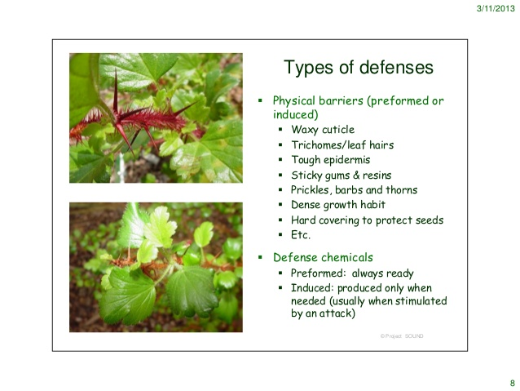
Student Notes

6.L.1.2 I can explain the processes of photosynthesis in plants.
a) I will determine the materials needed for photosynthesis.
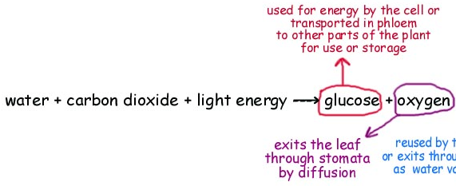
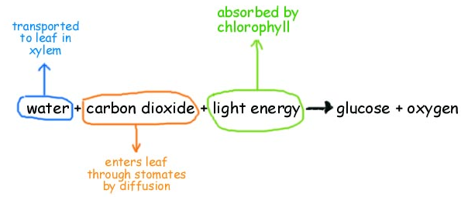
b) I will explain how chlorophyll is used in the process of photosynthesis.
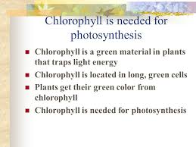
c) I will give examples of the products made by photosynthesis.
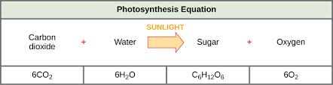
Student Notes

I can explain the importance of cellular respiration to the survival of green plants and all other organisms.
a) I will determine the materials needed for cellular respiration.
b) I will recognize that all living things perform cellular respiration.
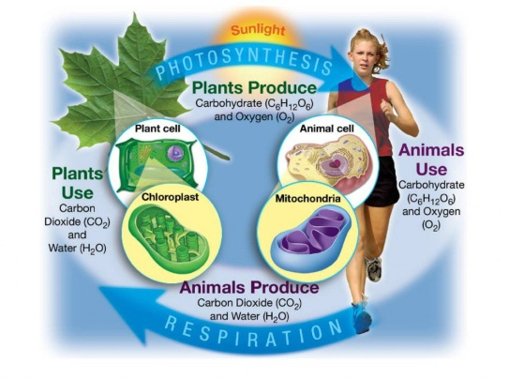
I can explain the significance of the processes of transpiration to the survival of green plants and other organisms.
I will recognize that the process of the loss of water is transpiration.
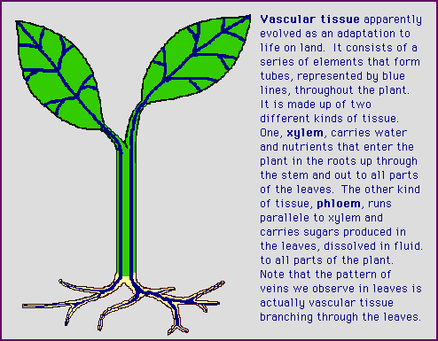
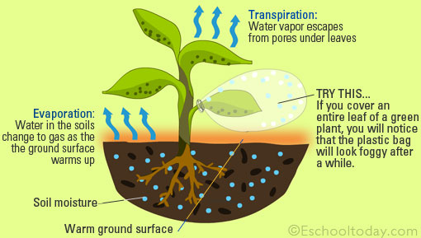
Student Notes

I will recognize that the process of the loss of water is transpiration. (continued)
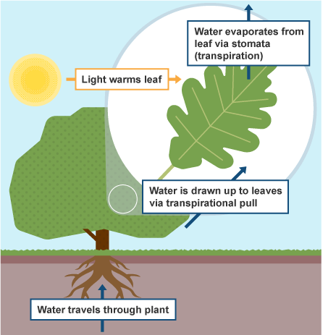
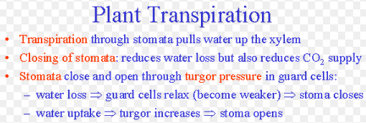
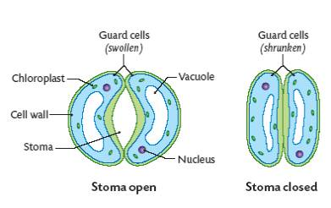

Student Notes

